**Advanced Safety Helmet For Workers**

**Mrunal Jadhav1, Niraj Mistri2, Akansha Pole.3 Arti Tekade4**

Department of Electronics and Telecommunication,

Pimpri Chinchwad college of engineering and Research, Ravet, Pune, India.

**ABSTRACT**

Mining is world's most dangerous professions. In some nations, underground miners lack safety and social protection, be left to fend for themselves if injured. Additionally, there are adverse societal repercussions, including displacement and loss of livelihood. Mining has the greatest fatality rate of any industry. The most workplace fatalities poisoning, and electrocution. There are various case studies regarding underground mines; for example, a recent case study in China indicated that underground mining is the world's deadliest business. disasters, we developed a more advanced communication technology that must work in tandem with an intelligent sensing and warning system. The most critical component in every business is safety. are paramount in the mining business. To avoid mishaps, the mining sector takes critical safeguards.

*Keywords:* Internet of Things, Global System for Mobile communication, Cloud Think Speak.

**INDEX TERMS:** Advanced safety helmet for workers with raspberry pi.

**I. INTRODUCTION**

In whatever form of construction, worker safety should always be a primary priority. Underground mining operations are a high-risk attempt in terms of worker safety and health. The diverse procedures utilized to harvest various minerals are to blame for these hazards. The deeper the mine, the higher the risk. These worries about safety are especially severe in the coal business. As a result, worker safety should be a major priority in any sort of mining, whether coal or other minerals. Underground coal mining is more dangerous than open pit mining due to ventilation concerns and the possibility of collapse. The use of heavy machinery and excavation procedures, pose safety dangers in all types of mining. Modern mines routinely adopt a wide range of safety protocols, worker education and training, and health and safety requirements, resulting in substantial modifications and improvements in both opencast and underground mining. Coal India's principal and it has played rapid industrial development. Coal provides for around 70% of power generation, making its significance in the energy sector essential. However, additional byproducts of represent a possible the people involved. Instead, the current effort is a genuine attempt to analyze gravity real-time detection monitoring WIFI technology.

**II. METHODOLOGY**

* Safety is the most critical part of every industry. The mining business prioritizes safety and security. To avoid any form of accident, the mining sector takes several fundamental safeguards.
* Accidents continue to occur in underground mines as a result of rising temperatures, rising water levels, and methane gas leakage. Here, we ensure worker safety.
* 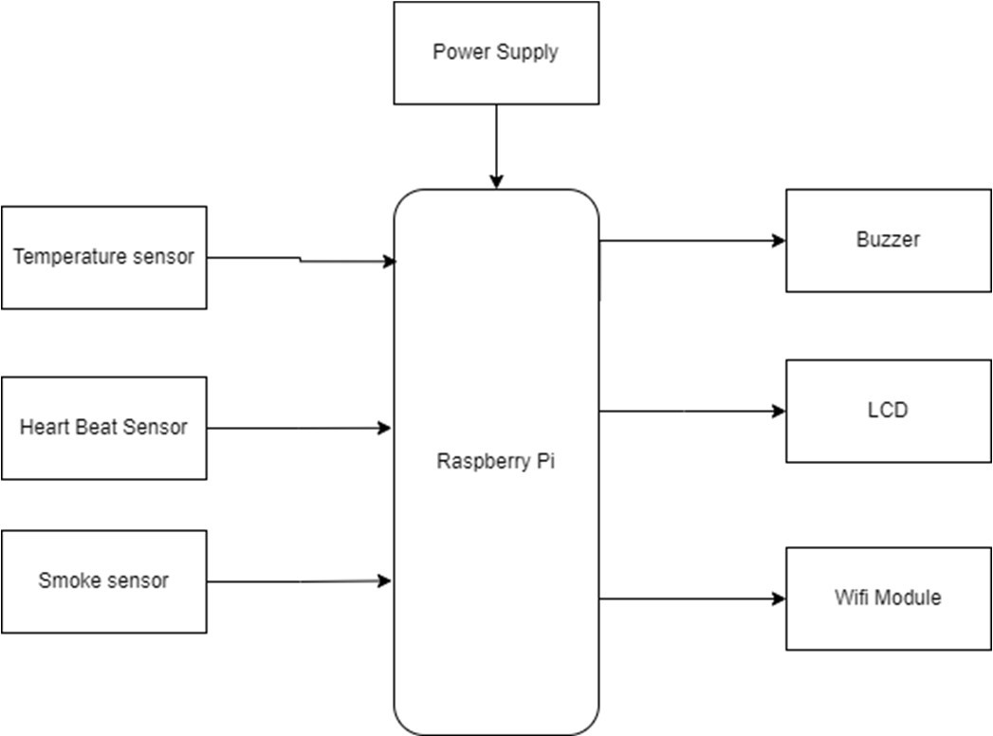If a worker is in danger, he can call security by pressing the panic button. To increase underground mine safety, a reliable communication system between subterranean mine workers and the fixed ground mining system must be built. At no time or under any circumstances should the communication network be disrupted. This concept proposes a low- cost wireless mine surveillance system based on IOT.

**III. EXPECTED MODEL**

Firstly, the hazardous gases are detected using gas sensors. Whenever the poisonous gas is detected the solenoid valve gets opened for providing oxygen supplements.

In the project raspberry pi is the main controller . System is able to monitor the health conditions of the worker as well as surrounding conditions. Also, if the worker health disturbed system will send the alert message.

In the system temperature sensor, heartbeat sensor, smoke sensor , buzzer, WIFI module is used. Sensors will read the values and send it to the controller . If the conditions of environment changes like if smoke at the workers end increases system send alert. Hence our system is helpful for the worker.

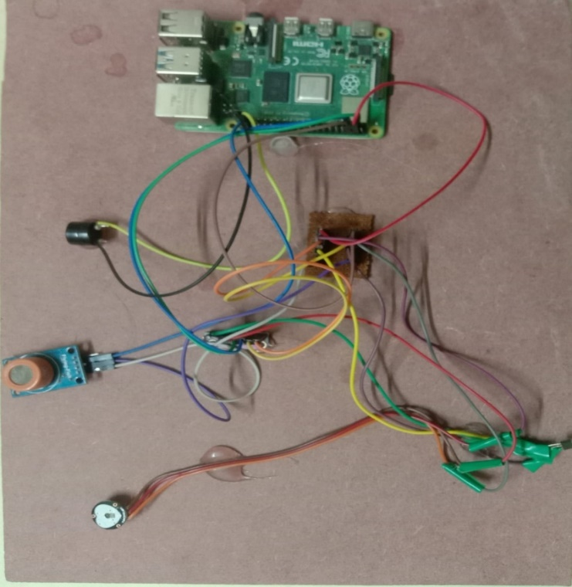

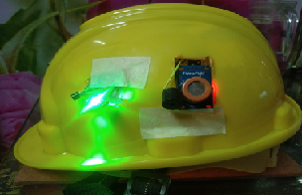

**IV. FLOWCHART**

A flowchart is a picture of the separate steps of a process in sequential order. It is a generic tool that can be adapted for a wide variety of purposes, and can be used to describe various processes, such as a manufacturing process, an administrative or service process, or a project plan.

Above figure represents the algorithm of the whole project in an easier and simplest form.

When the system starts it receives data from the workers unit future the received data parameters are displayed on the monitor display depending upon the environmental conditions the state of buzzer is decided the final data is send to the cloud think speak and is saved in the cloud.

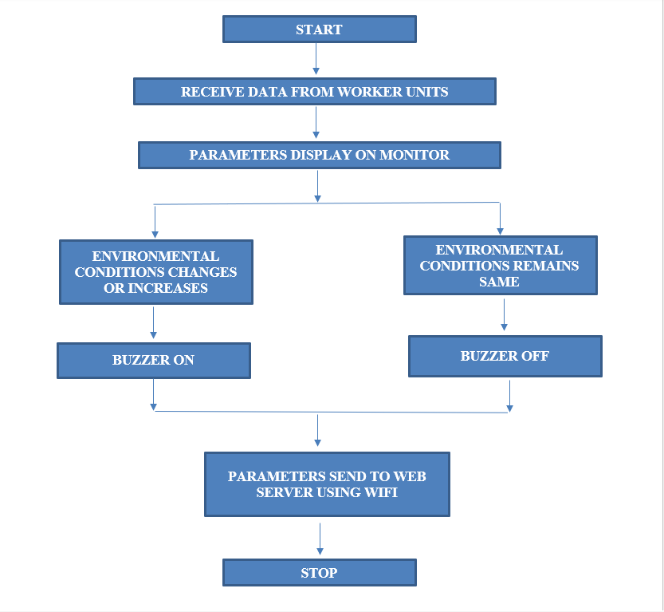

**VII. CONCLUSION**

In this paper, we have implemented Safety Helmet the proposed methodology aids in both the prevention of workplace accidents and the preservation of society's cleanliness. The smart safety gadget is less expensive and more quickly connects and transmits data to emergency department. Therefore, a smart helmet for detecting dangerous environmental conditions, monitoring workers heartrate and antique the information and the sensed data with the help of sensors to the control main unit for easy tracking and providing oxygen supplements to avoid the inhalation of hazardous gases is intended.

**REFERENCES**

1. Chang A.Y, Chang-Sung Yu, Sheng-Zhilin Lin-Yeh Chang, Pei-Chi Ho, ‘Search, Identification and Positioning of the Underground Manhole with RFID Ground Tag’ INC, IMS and IDC, 2009. NCM ’09.Fifth International Joint Conference on vol no. pp.1899, 1903 25-27 Aug.2009.
2. M. Maroti, B. Kusy, G. Simon, and A. Ledeczi, “The flooding time synchronization protocol,” in Proc. ACM SenSys’04, Baltimore, MD, November 2004.
3. Wemer Allen, G., Johnson, J., Ruize, M., Less, J., and Welsh, Matt ‘Monitoring Volcanic Eruptions with a Wireless sensor Network’. Proceedings of 2nd European Workshop on Wireless Sensor Network, 2005.
4. ZigBee Alliance, “Understanding ZigBee gateway”, ZigBee Document 095465r13, September 2010.
5. Sobin, C. C. "A survey on architecture, protocols and challenges in IoT." *Wireless Personal Communications* 112, no. 3 (2020): 1383-1429.
6. Malakahmad, A., Downe, A.G. and Fadzil, S.D.M., 2012, April. Application of occupational health and safety management system at sewage treatment plants. In 2012 IEEE Business, Engineering & Industrial Applications Colloquium (BEIAC) (pp. 347-350). IEEE.
7. Zhou, Mudi, Zhuli Fang, Bin Zhao, and Pengfei Li. "Safety Helmet Wearing Detection and Recognition Based on YOLOv4." In 2021 3rd International Academic Exchange Conference on Science and Technology Innovation (IAECST), pp. 798-802. IEEE, 2021.
8. Gao, Yumin, Yan Liu, Daojin Nie, Ziming Huang, Bin Li, and Bing Qian. "An Efficient Safety Helmet Detection based on Attentional Mechanism." In 2021 7th International Symposium on System and Software Reliability (ISSSR), pp. 97-98. IEEE, 2021.
9. Ren, Dacong, Tongsheng Sun, Cungui Yu, and Cheng Zhou. "Research on Safety Helmet Detection for Construction Site." In 2021 International Conference on Computer Information Science and Artificial Intelligence (CISAI), pp. 186-189. IEEE, 2021.
10. Sharma, Susanta, Allumallu Veera Venkata Susmitha, Lan-Da Van, and Yu-Chee Tseng. "An Edge-Controlled Outdoor Autonomous UAV for Colorwise Safety Helmet Detection and Counting of Workers in Construction Sites." In 2021 IEEE 94th Vehicular Technology Conference (VTC2021-Fall), pp. 1-5. IEEE, 2021.
11. Biradar, Priya, Priyanka Kolsure, Sujata Khodaskar, and Kishor B. Bhangale. "IoT based smart bracelet for women security." *Int. J. Res. Appl. Sci. Eng. Technol.(IJRASET)* 8, no. 11 (2020): 688-691.
12. Sarraf, Rajan, Shalini Ojha, Damini Biraris, and Kishor B. Bhangale. "IoT based smart quality water management system." *International Journal* Of Advance Scientific Research And Engineering Trends, 5, no. 3 (2020).
13. Mapari, Rahul, Kishor Bhangale, Laukik Deshmukh, Prashant Gode, and Ankit Gaikwad. "Agriculture Protection from Animals Using Smart Scarecrow System." In *Soft Computing for Security Applications*, pp. 539-551. Springer, Singapore, 2022.
14. Kun Han ,Deep Learning-Based Workers Safety Helmet Wearing Detection on Construction Sites Using Multi-Scale Features Published in: IEEE Access ( Volume: 10) Page(s): 718 – 729, 2021.
15. Huang, Li, Qiaobo Fu, Meiling He, Du Jiang, and Zhiqiang Hao. "Detection algorithm of safety helmet wearing based on deep learning." *Concurrency and Computation: Practice and Experience* 33, no. 13 (2021)